

**PRESIDENCY UNIVERSITY**

A Report on

**“SMART DUSTBIN USING ARDUINO”**

A technical project work submitted in partial fulfilment of requirement for the award of the degree of

**Bachelor of Technology**

**In**

**Computer Science and Engineering**

**By**

* **ID NUM:20181CSE0249( G.V.BRAMHATEJA)**
* **ID NUM:20181CSE0124 (C.SMRITI)**
* **ID NUM:20181CSE0094(B.JANSI)**

Under the guidance of

**Mr.Mohammed Mujeer Ulla M. Tech**

Archana Sasi madam, Dept. of CSE

**Contents to be included in the report**

**INDEX**

* **aim of the project**
* **components required**
* **circuit diagram**
* **under implementation include code, hardware prototype image**
* **Conclusion**
* **Reference**

**AIM OF THE PROJECT;**

**TO DEVELOP AN IOT BASED SMARTDUSTBIN OF ULTRASONIC SENSOR AND SMS SYSTEM BY USING ARDUINO UNO BOARD..**

**Components Required:**

* **ARDUINO UNO**
* **ULTRASONIC SENSOR**
* **9G SERVO MOTOR**
* **9V BATTERY**
* **RESISTOR**
* **8GSM MODULE SIM 800A**

**CIRCUIT DIAGRAM:**

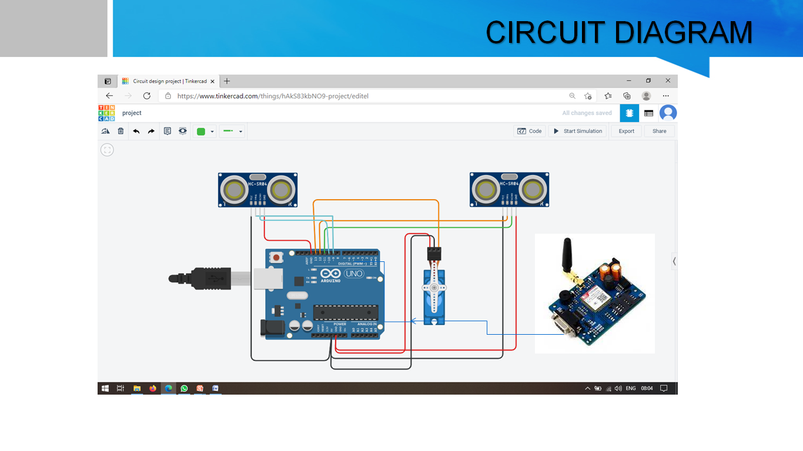

**Components Connection:**

**CONNECTIONS WITH ULTRASONIC SENSOR WITH ARDUINO:**

* **VCC->ARDUINO +5V**
* **GND->ARDUINO GND PIN**
* **TRIG->ARDUINO DIGITAL PIN 9**
* **ECHO->ARDUINO DIGITAL PIN 10**

**CONNECTION WITH GSM MODULE:**

* **GND->ARDUINO GND PIN**
* **TX->ARDUINO DIGITAL PIN 2**
* **RX->ARDUINO DIGITAL PIN 3**

**CONNECTIONS WITH ULTRASONIC SENSOR WITH ARDUINO2:**

* **VCC->ARDUINO +5V**
* **GND->ARDUINO GND PIN**
* **TRIG->ARDUINO DIGITAL PIN 11**
* **ECHO->ARDUINO DIGITAL PIN 12**

**CONNECTIONS WITH 9G SERVO WITH ARDUINO:**

* **VCC->ARDUINO +5V**
* **GND->ARDUINO GND PIN**
* **SIGNAL->ARDUINO DIGITAL PIN**

**Code:**

**#include <Servo.h>**

**Servo servoMain; // Define our Servo**

**#include<SoftwareSerial.h>**

**#define trigPin 9**

**#define echoPin 10**

**SoftwareSerial mySerial(2, 3);**

**int normalDistance;//**

**boolean triggered = false;**

**long duration, distance;**

**int trigpin1 = 12;**

**int echopin1 = 11;**

**int distance1;**

**float duration1;**

**float cm1;**

**void setup()**

**{**

**servoMain.attach(13); // servo on digital pin 13**

**pinMode(trigpin1, OUTPUT);**

**pinMode(echopin1, INPUT);**

**mySerial.begin(9600);**

**Serial.begin (9600);**

**delay(100);**

**pinMode(trigPin, OUTPUT);**

**pinMode(echoPin, INPUT);**

**long duration, distance;**

**while (millis() < 5000)//for first 5 seconds disance is measured**

**{**

**digitalWrite(trigPin, LOW);**

**delayMicroseconds(2);**

**digitalWrite(trigPin, HIGH);**

**delayMicroseconds(10);**

**digitalWrite(trigPin, LOW);**

**duration = pulseIn(echoPin, HIGH);**

**distance= duration*0.034/2;**

**normalDistance = distance;**

**Serial.print("Distance: ");**

**Serial.println(distance);//length of dustbin is calculated**

**} }**

**void loop()**

**{**

**digitalWrite(trigpin1, LOW);**

**delay(2);**

**digitalWrite(trigpin1, HIGH);**

**delayMicroseconds(10);**

**digitalWrite(trigpin1, LOW);**

**duration1 = pulseIn(echopin1, HIGH);**

**cm1 = (duration1/58.82);**

**distance1 = cm1;**

**if(distance1<30)**

**{**

**servoMain.write(180); // Turn Servo back to center position (90 degrees)**

**delay(300);**

**}**

**else{**

**servoMain.write(0);**

**delay(50);**

**}**

**digitalWrite(trigPin, LOW);**

**delayMicroseconds(2);**

**digitalWrite(trigPin, HIGH);**

**delayMicroseconds(10);**

**digitalWrite(trigPin, LOW);**

**duration = pulseIn(echoPin, HIGH);**

**distance= duration*0.034/2;**

**Serial.print("Distance: ");**

**Serial.println(distance);**

**if (distance < normalDistance-5)**

**{**

**triggered = true;**

**}**

**else**

**{**

**triggered = false;**

**}**

**if (triggered)**

**{**

**mySerial.println("AT+CMGF=1");**

**//Sets the GSM Module in Text Mode**

**delay(60000);**

**mySerial.println("AT+CMGS=\"+91xxxxxxxxxx\"\r");**

**// Replace x with mobile number**

**delay(1000);**

**mySerial.println("dustbin no. 1 at ____ is full. kindly empty it.");**

**// The SMS text you want to send delay(100);**

**mySerial.println((char)26);**

**// ASCII code of CTRL+Z**

**delay(1000);**

**} }**

**Hardware prototype image:**

**Component connections**

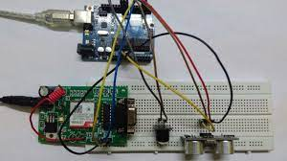

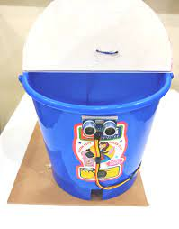

**CONCLUSION:**

* **SIMPLE BUT USEFUL PROJECT CALLED SMART DUSTBIN USING ARDUINO IS DESIGNED AND DEVELOPED HERE.**
* **USING THIS PROJECT,THE LID OF THE DUSTBIN STAYS CLOSED,SO THAT WASTE IS NOT EXPOSED(TO AVOID FLIES AND MOSQUITOS) .**
* **WHEN YOU WANT TO DISPOSE ANY WASTE,IT AUTOMATICALLY OPENS THE LID.**

**APPLICATIONS:**

* **TO COLLECT DUSTBINS PLACED AT PUBLIC PLACES IN CITY**
* **AUTOMATIC OPEN-CLOSE LID EASE OF USE**
* **THERE IS NO CONTACT BETWEEN DUSTBIN AND THE PERSON SO THERE WILL BE NO TRANSMIT OF GERMS AND DISEASES.**
* **WARNING MESSAGE SENT TO GARBAGE COLLECTOR WHEN ITS FULL**